|  |
| --- |
| **Cost-Benefit Analysis** |
|

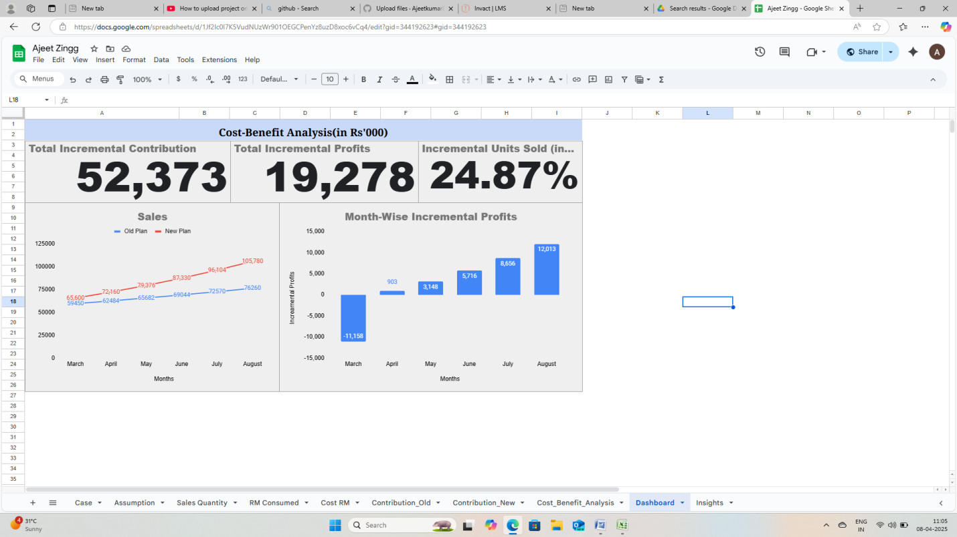

|  |  |
| --- | --- |
| Report for Management | |
| 1 | In new Plan the forecast is that the sales quantity will be 24.87% higher than the old Plan forecast. |
| 2 | Cost-Benefit analysis of new plan shows that it will generate an incremental profits of Rs.19,278,000. |